**An analysis of impact on remittance flow in Bangladesh**

# Abstract

This comprehensive analysis delves into the complex dynamics of remittance flows in Bangladesh and its multifaceted impact on the country's economic, social and development landscape. As Bangladesh is one of the world's leading remittance-receiving countries, this study explores the historical migration patterns dating back to the early 1970s that have fueled the growth of remittances. Challenges and opportunities were identified, including the need to improve access to finance, invest in education and skills development, protect consumers, diversify the economy, attract diaspora communities and continue research to develop policies. Remittances represent the foundation of Bangladesh's economy, offering significant potential to spur growth and development. By implementing the recommended strategies and policies, Bangladesh can harness the full potential of remittance flows to propel the nation towards sustainable prosperity and well-being. Remittances have become the mainstay of Bangladesh's economy, influencing the country's economic, social and development trajectory. This analysis will undertake an in-depth exploration of each of these aspects, using a multifaceted analytical lens to provide a comprehensive understanding of the impact of remittances on Bangladesh. Additionally, it will examine the challenges and opportunities that arise in a remittance-dependent economy and provide informed policy recommendations to maximize benefits while minimizing potential risks. Through this in-depth review, we aim to contribute meaningfully to the ongoing discussion on the role of remittances in Bangladesh's future.

**Keywords:** Remittance, Migration, Invest, Trajectory.

Table of Contents

**Abstract 1**

**Introduction 3**

**Literature review 4**

**Methodology 6**

**Data Collection 6**

**Type of the research 6**

**Information Required 6**

**Data collection method 6**

**Sampling techniques and sample size: 7**

**Data Analysis 7**

**Demography 8**

**Findings 16**

**Conclusion 17**

**Recommendations 17**

**Limitations and Future Study 18**

**References 19**

# Introduction

Remittances play a central role in Bangladesh's economic landscape, as they constitute a significant part of the country's outward capital flows and have far-reaching consequences for both the macroeconomy as well as livelihoods. plans of millions of households. Over the past decades, Bangladesh has experienced significant growth in remittance flows, making it one of the world's leading remittance-receiving countries. This article aims to provide a comprehensive analysis of the impact of remittances on Bangladesh, focusing on economic, social and development aspects (Barai, 2012).

Economic activity increased due to economic globalization. The 1980s and 1990s led to a rapid increase in international demand for skilled and unskilled workers. This paved the way many people, including those in developing countries, travel to external destinations (Castles & Davidson, 2000). For a large number of Bangladeshi workers, it is mainly low-skilled and unskilled, this external demand has opened up opportunities to make a living abroad. Many others have also left country with respect to different attractive and repulsive factors. However, this is a welcome relief for Bangladesh as its development strategies since independence have not been able to meet and meet the growing job demand at a rapid pace population growth. Consequences of multidimensionality resettlement of people, both temporary and permanent, is remittances have increased rapidly in the Bangladesh economy.

However, over time, there appears to have been a shift in the composition of migration from Bangladesh, especially between the pre- and post-independence periods, as temporary labor migration now accounts for the overwhelming proportion of the total. number of migrants. This wave of short-term migration is again mainly focused on Asia due to rapidly growing labor demand in many economies in the region. As we know, the huge investments in infrastructure of Middle Eastern countries caused by petrodollars2 forced some Arab countries to look for external labor since the mid-1970s. However, the development of rapid economic development newly industrialized economies (NIE)3 in the 1980s and 1990s, along with Japanese demand, created high demand for cheap foreign labor in the East and Southeast Asia region (Cruz, 2005). These two economic events have created short-term job opportunities for workers in many countries with a surplus of labor, including Bangladesh. Currently, according to estimates from the World Bank's Migration and Remittances Factbook (MRF) 2011, Bangladesh has a total of 5.38 million migrants, equivalent to 3.3% of the total population (Bank, 2010). Of those, a significant portion are now based in Asia, especially in the Middle East, East and Southeast Asia. However, the long-term direction of migration from Bangladesh remains largely towards the West and other developed countries around the world, although a gradual shift is taking place as more and more people migrate to developing economies. develop for long-term settlement.

However, the link between the development impact of remittances and the socioeconomic variables of the receiving economy depends largely on the recipient's usage patterns. In other words, the development relationship of remittances can be considered through their use for consumption, savings, education, health care, business, asset holding, and debt repayment., etc. of beneficiary households. Even if the establishment of such an association is considered complicated, researchers have recently become interested in it. For a developing country like Bangladesh, the importance of remittances for the development of economic and social sectors seems to have a solid basis if we see the argument that in underdeveloped countries financial development, remittances promote growth and are an alternative method of financing investments (Giuliano & Ruiz-Arranz, 2009).

# Literature review

In most cases, the first impact of remittances on economic development is felt at the migrant household level (Taylor & Wyatt, 1996) as remittances move in targeted flows. consumption, from person to person. (Ratha and Mohapatra, 2007). In fact, remittances bring additional funds to beneficiary households, which they can use to increase consumption, better access to education and health services, housing and good living conditions. as well as use resources in production activities (Thao, 2023). Finally, remittances from immigrant workers supplement national savings to form a larger pool of resources for investment (Carling, 2004). Hugo (Hugo, 2003) argues that remittances represent a significantly greater redistribution of wealth than FDI and ODA, mainly due to the absence of any conditionality (attached to ODA) and repatriation opportunities (of FDI). At the macro level, these phenomena culminate in a chain of aggregate demand - production - increasing income, which ultimately affects the growth of the economy. However, the sustainability of this process may be debated because development impacts cannot be long-lasting unless migrants' participation in remittances is institutionalized. This remains a problem in Bangladesh because the use of informal channels4 to send remittances is widespread, making institutionalization somewhat difficult.

Remittances are money sent by Bangladeshi workers abroad to their families and communities back home. Bangladesh has a long history of labor migration to countries such as the Middle East, Malaysia and the United States. The emergence of a global labor market, with its growing demand for low-skilled and semi-skilled workers, has created opportunities for Bangladeshi workers to seek employment abroad. This migration phenomenon began in the early 1970s and has grown significantly since then (Barua, 2007).

The economic impact of remittances on Bangladesh is multifaceted. First, remittances contribute significantly to the country's foreign exchange reserves, thereby helping to stabilize the balance of payments. This influx of foreign currency allows Bangladesh to finance its import obligations and foreign debt, thereby reducing the economy's vulnerability to external shocks. Second, remittances have a positive impact on exchange rates. Increased supply of foreign currency in the domestic market puts pressure on the Bangladeshi Taka exchange rate, making it stronger against major currencies. This can help control inflation by reducing the cost of imported goods and services. Third, remittances stimulate domestic consumption and investment. When remittance-receiving households receive remittances from relatives working abroad, they often spend part of this money to improve their living standards, including investing in education, health care, housing and small business. This increased spending has a positive multiplier effect on the economy, leading to higher overall demand, job creation, and economic growth (Kumar, Hossain, & Osmani, 2018).

Remittances have a profound social impact in Bangladesh. They help reduce poverty and income inequality by providing a source of income for millions of families. Remittances sent through remittances are often used to meet basic needs such as food, shelter, and health care, thereby improving the overall well-being of receiving households. In addition, remittances play an important role in education and human resource development. Many families use the remittances to send their children to school or university, breaking the cycle of illiteracy and contributing to a more educated and skilled workforce. This in turn improves the country's productivity and competitiveness in the global economy (Hassan, Chowdhury, & Bhuyan, 2016).

Remittances also have a significant impact on Bangladesh's development. They constitute a steady source of income that can be channeled into various development projects and initiatives. For example, remittances play an important role in financing infrastructure projects such as roads, bridges and irrigation systems that improve the overall quality of life in rural areas. In addition, remittances can be a source of investment in small and medium-sized enterprises (SMEs). Many households receiving remittances use this capital to start or expand businesses, which not only creates jobs but also contributes to diversifying and recovering the economy (Siddiqui, 2004).

# Methodology

## Data Collection

* **Remittance Data:** The primary source of remittance data has been collected from official reports and statistics provided by the Bangladesh Bank, the central bank of Bangladesh. These reports contain comprehensive information on the inflow of remittances into the country, including the source countries, trends over time, and breakdowns by different categories such as purpose and recipient regions.
* **Household Surveys:** To understand the micro-level impact of remittances, household surveys will be conducted in select regions of Bangladesh. These surveys collected data on remittance-receiving households, their socio-economic characteristics, and the utilization of remittance funds. Random sampling techniques used as employed to ensure the representation of diverse households.

## Type of the research

This research has been studied based on quantitative analysis. A method by which collected data are analyzed through statistical techniques is considered quantitative analysis. As the data are collected through the survey method and analyzed collected data as multiple regression, ANOVA is tested by its numeric value. This type of research is quantitative.

## Information Required

To collect the required data, 23 questions were set in the questionnaire. Both open-ended and close ended questions were used. There are one open-ended question and twenty-two close-ended questions. Some of these questions have been given below-

* Does anyone in your family live abroad?
* In which country live?
* Has the family's income improved due to going abroad?
* How much income has increased compared to before?
* What has changed the quality of life as a result?
* How does remittance come to you from abroad?
* What difficulties have you faced in going abroad?
* Did the remittance come from abroad during Covid-19?
* How was the remittance that came in during Covid-19 compared to before?
* Was the amount of remittance that came in sufficient during the pandemic?
* If not, what difficulties have you faced?
* Has there been an incident of job dismissal during 2019 to 2022?
* What is the amount of money now after Covid-19?
* Do you know what is the role of remittance in Bangladesh economy?
* How to send money from Bangladesh to abroad?

## Data collection method

The gathered data are gathered in two ways. These are:

* **Primary Sources:** The survey method has been used in this study. For conducting quantitative analysis, a survey method has been selected. The questionnaire was made as a Google form and sent to social media for collecting data from online respondents. ¬
* **Secondary Sources:** Different articles from scholar.google.com, tour websites, other authentic websites, and prescribed books have been used to collect secondary data.

## Sampling techniques and sample size:

Data were collected from 113 respondents. Here a simple random sampling method has been used, and a sample size of 113 has been selected from the population. Most of them are students. And they are from Barishal University.

## Data Analysis

This selection reports the data and the associated analyses that have been carried out to arrive at the findings and insights. Data were collected from the respondents aged 14 to 34 years living in Dhaka. They provided data in the Google Forms used to house the questionnaire and helped the study reach its goal to some extent.

## Demography

Demography data includes age, gender, occupation, monthly income, marital status, and education. The following pie charts show data in these demographic dimensions.

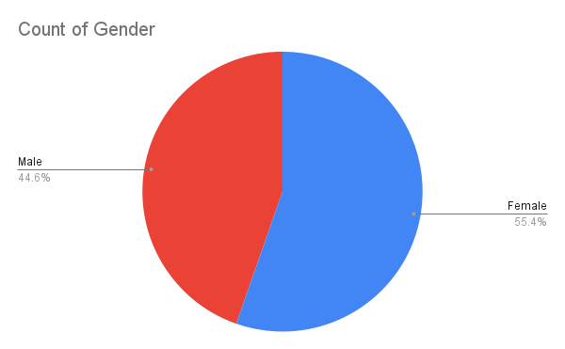

**Figure 1:** Gender

From 113 respondents most of them are female which is around 55.4% and rest of others are male.

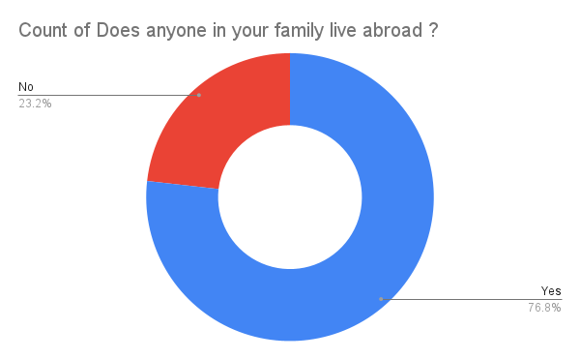

**Figure 2:** Living Abroad

From the respondents most of them have relatives in foreign country. The positive was about 76.8% and rest of others haven’t any relatives to the others country.

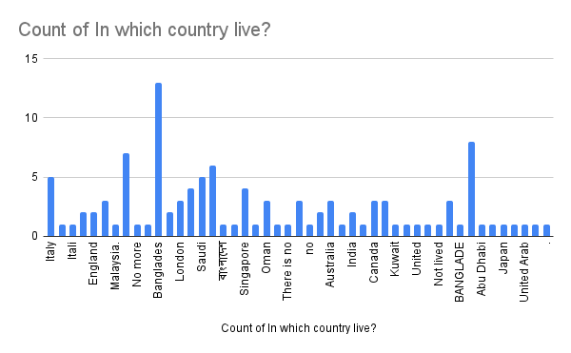

**Figure 3:** Choosing Country Live

By analyzing the Google Sheet, most of the respondents’ relatives live in Qatar which was about 7.1%. If we combined European Union, it would be the highest percentage that rest of others. Then Middle East countries will be the second highest where people’s relatives live in.

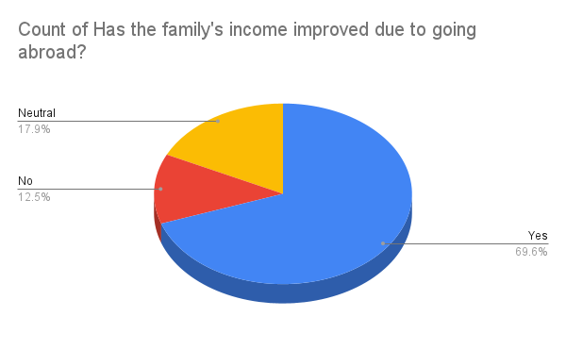

**Figure 4:** Improve Income or not

69.6% of respondents thought that family’s income improved due to going abroad. 12.5% didn’t think the same.

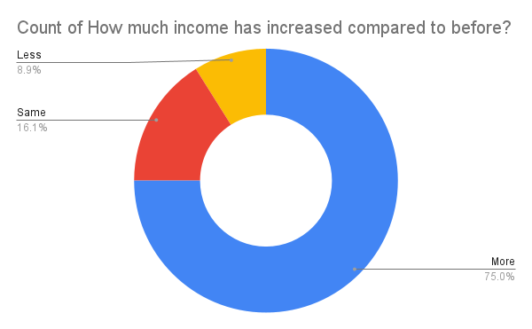

**Figure 5:** Income Increased or Not

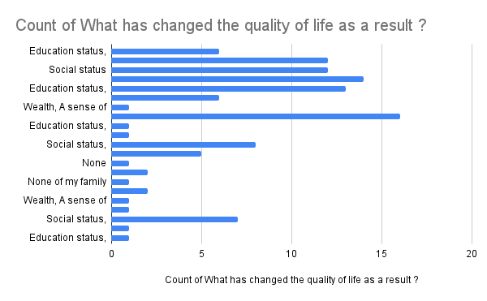As people go outside to improve their living style. So, it is important to know about that. Most of the respondents which is 75% believed that their income has been improved before going abroad. 16.1% thought it didn’t impact whether go outside or not and rest of 8.9% thought it decreased the income.

**Figure 6:** Changing Quality of Life

First people are not aware of going abroad. But people think of it. So, we have to know how could the know it more. Most of the respondents think education status, social status, wealth, a sense of security and safety, freedom are responsible for changing the quality of life and it was 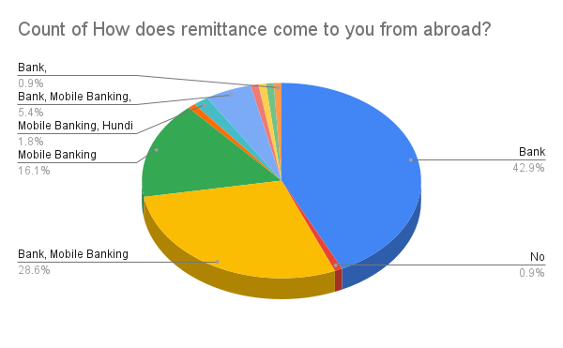about 14.3%.

**Figure 7:** Exchange Remittance

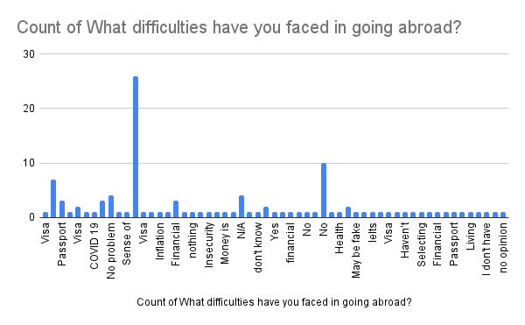The exchange of money is most important to the economy. 42.9% people completed it through bank.

**Figure 8:** Facing Difficulties to Abroad

The most common thing is to know why people choosing abroad over choosing their own country. 23.2% respondents think that they choose it for recovery their financial problems.

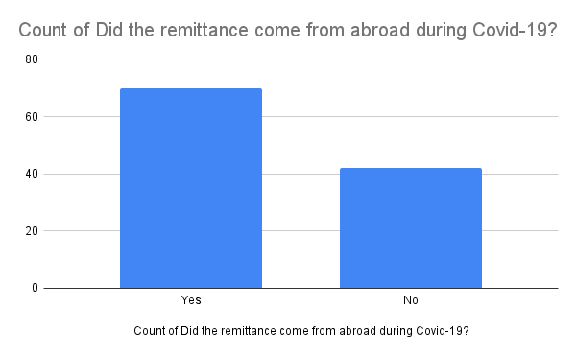

**Figure 9:** Counting Remittance

Most of the Respondents which is about 62.5% agree that the remittance come from abroad during Covid-19. And rest of others don’t.

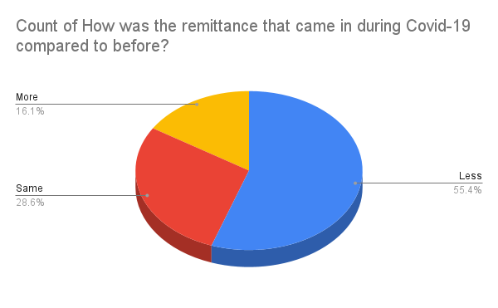

**Figure 10:** Remittance before Covid-19

Most of the respondents think it went less after Covid-19 which is about 55.4%.

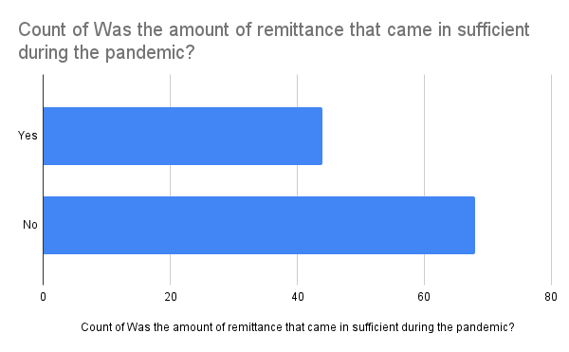

**Figure 11:** Was Remittance Sufficient or Not

Most of respondents think it was son sufficient during pandemic.

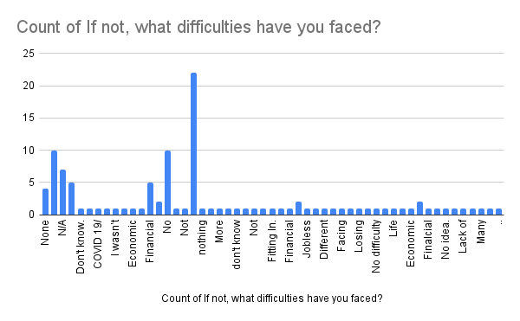

**Figure 12:** Difficulties They Faced

The most common difficulty was financial problem.

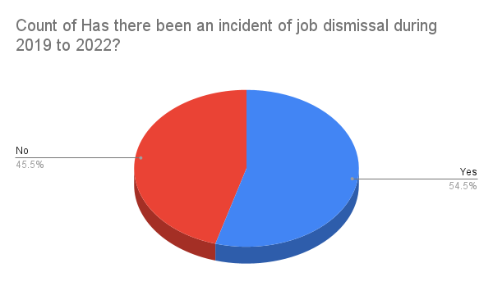

**Figure 13:** Job Dismissal During 2019-2022

Most of the respondents agreed that statement which is about 54.5% and rest of others don’t.

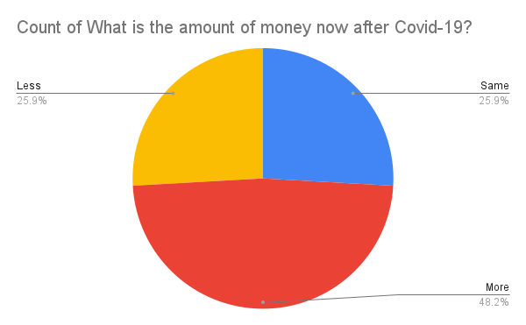

**Figure 14:** Amount of Money after Covid-19

48.2% participant think amount of money is more. Rest of others think same and less which is equal percentage.

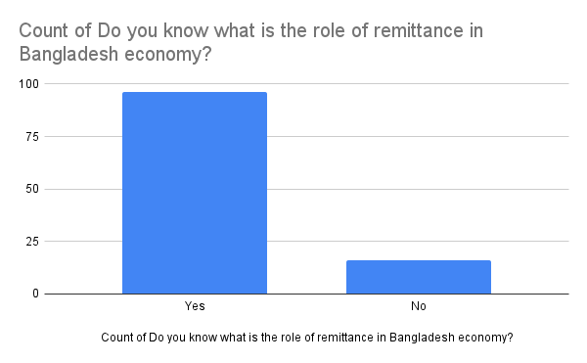

**Figure 15:** Most of the participants are agree with knowing role of remittance.

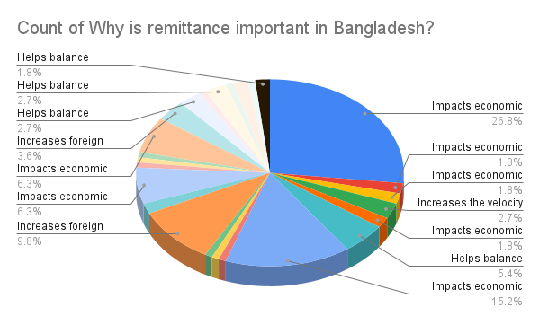

**Figure 16:** Importance of Remittance

Most of the participants think it impacts the economy which is about 26.8%.

# Findings

* **Remittances as an Economic Pillar:**
* Remittances have emerged as a vital pillar of Bangladesh's economy, contributing significantly to foreign exchange reserves, economic stability, and the balance of payments.
* The influx of remittances positively affects the exchange rate, mitigating inflationary pressures and reducing the cost of imported goods and services.
* Remittances stimulate domestic consumption and investment, generating increased aggregate demand, job creation, and overall economic growth.
* **Social Impact and Poverty Alleviation:**
* Remittances play a crucial role in poverty reduction and income inequality by providing a stable source of income to millions of households.
* Funds from remittances are often directed towards meeting basic needs such as food, shelter, and healthcare, ultimately improving the standard of living for recipient households.
* Remittances contribute significantly to education and human capital development, fostering a more educated and skilled workforce.
* **Developmental Contributions:**
* Remittances have been instrumental in financing critical infrastructure projects, particularly in rural areas, enhancing the quality of life for local communities.
* Investment of remittance funds in small and medium-sized enterprises (SMEs) promotes economic diversification, job creation, and resilience.
* **Challenges and Opportunities:**
* While remittances offer immense opportunities, challenges such as limited financial inclusion, inadequate skills development, and consumer protection issues need to be addressed.
* Diversification of the economy is necessary to reduce dependence on remittances for basic needs.
* Engaging with the Bangladeshi diaspora and creating opportunities for their involvement in development initiatives can further leverage the potential of remittances.
* Continuous research and monitoring are essential to inform evidence-based policymaking and address emerging trends and challenges.

# Conclusion

Remittances form an important pillar of the economic and social structure of Bangladesh. They have the potential to stimulate economic growth, reduce poverty and improve people's welfare. Effectively leveraging remittances while addressing challenges requires coordinated efforts between government agencies, financial institutions, NGOs and diaspora communities. By implementing the recommendations presented in this analysis, Bangladesh can maximize the positive impact of remittance flows and move the country towards prosperity and sustainable development.

# Recommendations

* **Diversify Investment Avenues for Remittance Funds:**

Promote financial education and savings programs to encourage deposit-receiving households to invest part of their money in financial instruments such as bonds, stocks or savings accounts to generate long-term returns long.

* **Enhance Financial Inclusion:**

Ensure that rural and remote areas have access to banking services, including mobile banking and microfinance. This will help reduce remittance transaction costs and promote savings. Encourage the adoption of digital financial services, such as mobile wallets and digital payments platforms, to make money transfers more accessible and efficient.

* **Improve Education and Skills Development:**

Allocate a portion of transfer funds to education and skills development programs. This will help create a more skilled and competitive workforce. Develop professional training programs suitable to labor market needs in the domestic and international context. This can improve the employability of potential immigrant workers.

* **Strengthen Consumer Protection:**

Enforce regulations and standards for remittance service providers to ensure transparency, fair fees, and secure transactions for immigrant workers and recipients. Educate senders and receivers on safe and cost-effective money transfer channels and methods.

* **Enhance the Role of Government:**

Strengthen supervision and regulation of capital flows to prevent illegal financial activities, such as money laundering and fraud. Continue to invest in infrastructure development, especially in rural areas, to improve overall quality of life and boost local economies.

* **Foster Financial Literacy:**

Develop and implement financial education programs for senders and recipients, ensuring they understand how to manage their finances effectively. Leverage mobile apps and online platforms to deliver financial education content, making it accessible to a wider audience.

* **Promote Diaspora Engagement:**

Create platforms and programs to engage the Bangladeshi diaspora in the country's development efforts. Encourage them to contribute to projects in their home communities. Consider issuing remittance investment bonds to enable the diaspora to invest in development projects in Bangladesh, thereby giving them a stake in the country's growth.

* **Address Economic Vulnerabilities:**

Encourage economic diversification to reduce dependence on remittances. This involves promoting export-oriented industries and attracting foreign direct investment. Establish a strong social safety net to protect vulnerable populations, thereby reducing their dependence on remittances for their basic needs.

* **Data and Research:**

Establish a system of continuous monitoring and research on remittance trends, their impact and emerging challenges. This will inform evidence-based policy making. Provide research grants to institutions and scholars to conduct in-depth research on various aspects of remittances and their impact on Bangladesh.

# Limitations and Future Study

Every study has its’ limitations and scope for further research. I have tried and worked at my best to collect the necessary data about Nation Brand and include all this information in this study. I have included information about ecotourism behavior and country image as well. But I have faced some limitations. These are:

* **Lack of knowledge:** As a student, I have little experience in collecting, analyzing and interpreting data.
* **Data collection process:** As the data collection process is so time-consuming and difficult to collect, I have faced some problems regarding this.
* **Lack of representative data:** I didn’t collect all over the country. Most of my data has been collected from the Dhaka and Barishal divisions. So, data have a lack of representation. Future studies can be carried out with more respondents and include a more diverse range of data.
* **Shortage of data:** This research is completed with 113 respondents due to a lack of time, resource constraints, and other limitations.

# References

Bank, W. (2010). Migration and Remittances Factbook 2011. *Washington, DC: Migration and Remittances Unit, Author*.

Barai, M. K. (2012). Development dynamics of remittances in Bangladesh. *Sage Open*, 2.

Barua, S. (2007). Determinants of workers’ remittances in Bangladesh: An empirical study. *Policy Analysis Unit (PAU)*, 713.

Carling, J. (2004). *Policy options for increasing the benefits of remittances.* Oxford, Uk: University of Oxford, Centre on Migration Policy and Society.

Castles, S., & Davidson, A. (2000). *Citizenship and migration: Globalization and the politics of belonging.* New York: NY: Routledge.

Cruz, G. T. (2005). Migration in the Asian region: Retrospect and prospects. *World Mission*, 22-26.

Giuliano, P., & Ruiz-Arranz, M. (2009). Remittances, financial development, and growth. *. Journal of Development Economics*, 144-152.

Hassan, G. M., Chowdhury, M., & Bhuyan, M. (2016). Growth effects of remittances in Bangladesh: Is there a U‐shaped relationship? *International Migration*, 105-121.

Hugo, G. (2003). *Migration and development: A perspective from Asia (Migration Research Series No. 14).* Geneva, Switzerland: International Organization for Migration.

Kumar, B., Hossain, M. E., & Osmani, M. A. (2018). Utilization of international remittances in Bangladesh. *Remittances Review*, 5-18.

Siddiqui, T. (2004). Efficiency of migrant workers’ remittance: the Bangladesh case. *Asian Development Bank*.

Taylor, J. E., & Wyatt, T. J. (1996). The shadow value of migrant remittances, income and inequality in a household-farm economy. *Journal of Development Studies*, 899-912.

Thao, N. M. (2023, 09 20). *Economic Management*. Retrieved from Migration, remittances, and economic development: Case of Vietnam. Hanoi, Vietnam: Central Institute for Economic Management: https://docs.google.com/viewer?a=v&q=cache:OgIhw3NMGD8J:s3.amazonaws.com/zanran_storage/www.trf.or.th/ContentPages/16731190.pdf+Migration,+Remittances,+and+Economic+development:+Case+of+Vietnam.&hl=en&pid=bl&srcid=ADGEESjU6OH8CasjcL8ThvLepKwitRACpgknyC38J